**POKHARA UNIVERSITY**

**APEX COLLEGE**

Department of Management

**MINOR PROJECT REPORT ON**

“Secret Aura Frontend”

**BY**

Ayushma Gyawali- (24080011)

KATHMANDU, NEPAL

2025

**POKHARA UNIVERSITY**

**APEX COLLEGE**

Department of Management

**MINOR PROJECT REPORT ON**

“Secret Aura frontend”

**BY**

Ayushma Gyawali- (24080011)

A PROJECT WORK SUBMITTED TO THE DEPARTMENT OF MANAGEMENT IN PARTIAL FULFILLMENT OF THE REQUIREMENT FOR THE BACHELOR OF COMPUTER SYSTEM AND INFORMATION TECHNOLOGY

KATHMANDU, NEPAL

2025

**POKHARA UNIVERSITY**

**APEX COLLEGE**

Department of Management

The undersigned certify that they have read, and recommended to Pokhara University for acceptance, the project report titled **“[Secret Aura frontend]”** submitted by [Ayushma Gyawali-(24080011)] in partial fulfillment of the requirement for the Bachelor of Computer System and Information Technology.

|  |  |
| --- | --- |
| ______________________  **Supervisor**  **Rajiv Bikram Shah**  Lecturer, BCSIT  Apex College | ____________________  **External Examiner**  **Suraj Sharma Phuyal**  Database Engineer  TechKraft, Inc |
| _______________________  **External Examiner**  **Kiran Bishwokarma**  Fullstack Developer  Tryodesk |

# DECLARATION

The project report titled **“Secret Aura frontend”** submitted for the partial fulfillment of the requirement for the degree of Bachelor of Computer System and Information Technology to Pokhara University, comprises only original work and due acknowledgement have been made to the materials used in this report.

Ayushma Gyawali- (24080011)

25th July, 2025

# Acknowledgement

I would like to express my sincere gratitude towards Apex College for providing us with the opportunity to work on this minor project as a part of our course in Second Semester. I am also thankful to our project coordinator, Mr. Bharat Khanal and all our respective subject teachers for their guidance throughout the whole project whose contributions in stimulating suggestions and encouragements helped me finish this project.

I am especially grateful to our supervisor, Mr. Rajiv Bikram Shah, for his constant support, insightful feedback and direction at every stage of this project. I have put in my best efforts to minimize any errors by taking guidance from my supervisor, discussing with colleagues, referring to books and online resources, and seeking help from relevant personnel and organizations whenever needed.

Lastly, I would like to thank my peers and family members for always motivating and supporting me during the course of this project.

# Abstract

**Secret Aura** is a website created to showcase a luxury perfume brand through an elegant and visually appealing online presence. The platform is designed to present a limited yet premium collection of fragrances with a clean, modern interface that highlights the brand’s identity and style. It features pages such as homepage, collections, about, customer reviews, contact, and login.

This project report details the process of designing and developing the frontend of the Secret Aura website using **HTML, CSS, and JavaScript**. The goal was to build a fully functional and responsive frontend interface while enhancing skills in web development and UI design. The development included planning the structure, creating custom styles, adding interactivity, and testing across different devices. The results show a responsive and visually rich perfume website that successfully represents the brand. Future improvements may include adding backend features like data storage, form processing, and further optimizing the site for mobile and SEO.

Table of Contents

DECLARATION iv

Acknowledgement v

Abstract vi

CHAPTER 1 1

INTRODUCTION 1

1.1 Background 1

1.2 Scope 1

1.3 Project Description 1

1.4 Objectives 2

CHAPTER 2 3

LITERATURE REVIEW 3

CHAPTER 3 4

SYSTEM ANALYSIS, DESIGN, AND IMPLEMENTATION 4

3.1 System Design 4

3.2 User Flow Diagram 5

3.3 Wire Framing 6

3.4 System Description 9

CHAPTER 4 10

SYSTEM TESTING, DEBUGGING, AND RESULTS 10

4.1 Testing 10

4.2 Debugging 11

4.3 Results 11

CHAPTER 5 12

SUMMARY 12

5.1 Conclusion 12

5.2 Limitations 12

5.3 Future Enhancements/Recommendations 13

REFERENCES 14

APPENDICES 15

LIST OF FIGURES

Figure 1: User Flow Diagram 5

**LIST OF TABLES**

Table 1: Testing 9

LIST OF ABBREVIATION

HTML- Hyper Text Markup Language

CSS- Cascading Style Sheets

JS- JavaScript

DOM- Document Object Model

# CHAPTER 1

# INTRODUCTION

## 1.1 Background

Secret Aura is an elegant perfume brand website developed to showcase a crated selection of premium fragrance sprays. Inspired by the idea that everyone loves a pleasant scent, Secret Aura aims to provide customers with a simple yet captivating online space to explore limited but high-quality perfume options. The website focuses on beauty, uniqueness, and visual appealing design, matching the quality of the products it represents. With a smooth layout and easy-to-use interface, Secret Aura lets users browse featured perfumes and feel the brand’s personality online. The platform is entirely focused on the frontend, highlighting the aesthetic focusing on design and the user’s experience.

## 1.2 Scope

The scope of this project is limited to designing and implementing the frontend of the Secret Aura perfume website. This includes developing the main visual layout, product showcases, navigation elements, and basic interactivity using HTML, CSS, and JavaScript. Backend development, payment integration, and database functionality are not included in the current scope.

## 1.3 Project Description

This project focuses on developing the frontend of a perfume brand website titled “Secret Aura”. The website is designed with a minimal, maroon-theme to reflect luxury and elegance. Its main components include a homepage, featured perfume collections, and the user login and contact pages. The platform was developed using HTML for structure, CSS for styling, and JavaScript for interactive functionalities, ensuring a smooth and responsive user experience. The primary aim of this project is to demonstrate practical frontend development skills by creating a visually appealing and user-friendly brand interface that effectively showcases the products and enhances user engagement.

## 1.4 Objectives

The objectives of this project are as follows:

* Strengthen proficiency in frontend web development using HTML, CSS, and JavaScript.
* Create a visually appealing website consistent with a premium perfume brand identity.
* Implement basic interactivity to improve the user experience.
* Replicate a clean and engaging design using only code-based styling (without external design tools).
* Understand the process of building and structuring a fully functional frontend.
* Develop skills in layout design, styling, and project time management.

# CHAPTER 2

# LITERATURE REVIEW

The literature review highlights the importance of frontend development in creating effective and visually appealing web applications. Core technologies such as HTML, CSS, and JavaScript are widely used to build user interfaces that are both functional and attractive. Numerous online resources and tutorials exist to help learners master these technologies and improve their web development skills. However, many resources often focus only on basic concepts and design replication, without addressing real-world challenges such as responsiveness, cross-device compatibility, and performance optimization.

This project aims to bridge this gap by providing a practical approach to frontend development. By designing and developing the Secret Aura perfume brand website entirely from scratch using HTML, CSS, and JavaScript, the project offered hands-on experience in layout design, color theming, content organization, and integrating interactive features. These skills are essential for becoming proficient in frontend development and for creating websites that provide a seamless user experience.

# CHAPTER 3

# SYSTEM ANALYSIS, DESIGN, AND IMPLEMENTATION

## 3.1 System Design

The system design of the Secret Aura website was focused on building a visually attractive, smooth, and user-friendly interface to reflect the brand’s elegant and luxurious image. The goal was to provide users with a pleasant browsing experience while exploring limited, high-quality perfume collections. During the design phase, careful planning was done to decide the structure of each webpage, the color scheme (dark maroon tones), and the overall flow of the website.

Wireframes were created for key pages such as the Homepage, About Us, Collection, Most Demanded, Customer Reviews, Contact, and Login. These wireframes helped map out the layout of each section including the navigation bar, banners, product displays, review sections, and footer. The homepage includes the main introduction to the brand, links to major sections, and a footer with contact details. Other pages were kept simple and minimal to ensure easy navigation, with consistent styling and visual hierarchy across the website.

A user flow diagram was also developed to show how visitors move through the site. Users begin at the homepage, then can go to the Collection page to explore perfumes, view popular items in Most Demanded, read brand details in the About Us page, or check customer feedback. From there, they may head to the Contact page to fill out the form or access the Login page. This design ensures a smooth journey for users, guiding them clearly through each section without confusion.

## 3.2 User Flow Diagram

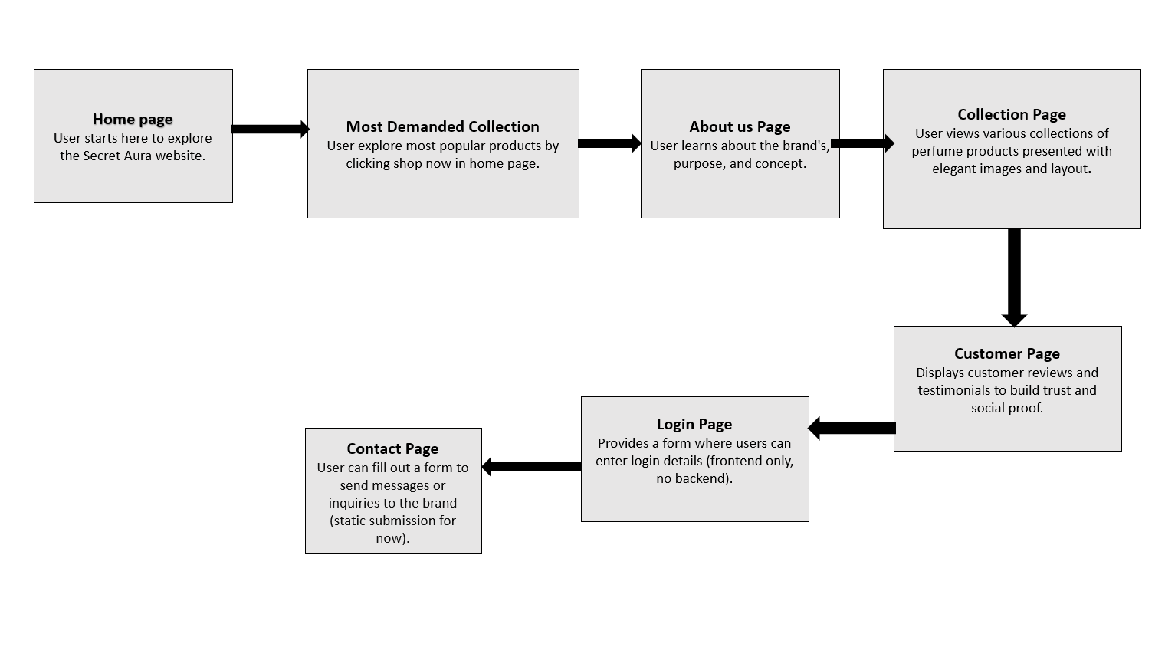A user flow diagram for the **Secret Aura project** illustrates the journey a user takes from landing on the homepage to exploring various features of the site, such as viewing collections, learning about the brand, reading customer reviews, and interacting with contact and login forms. This flow diagram helps visualize how users navigate through different sections to achieve their goals, such as discovering products or reaching out to the brand.

Figure 1: User Flow Diagram

## 3.3 Wire Framing

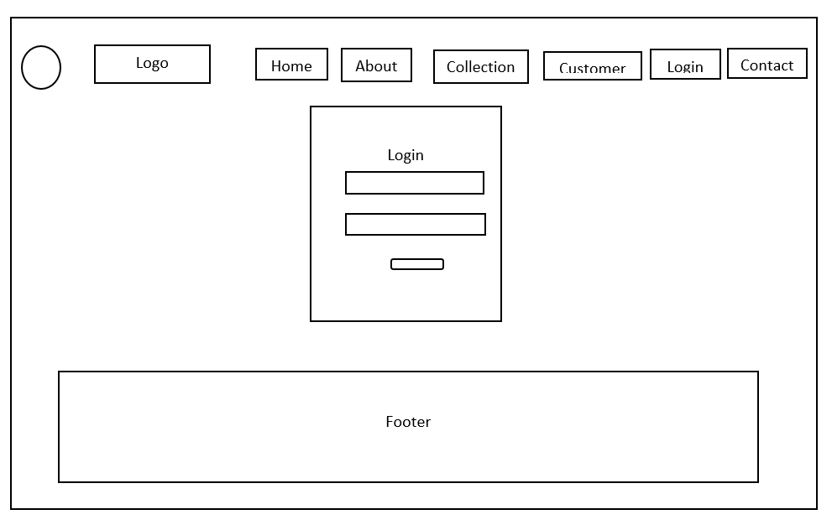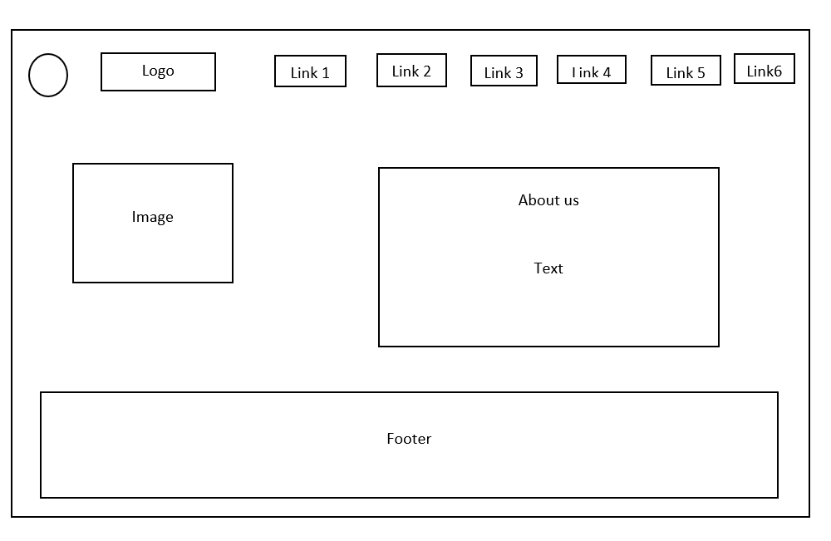*Figure 3: About us Wireframe*

*Figure 4: Login form Wireframe*

## *Figure 4: Collection Wireframe*

## 3.4 System Description

The system consists of HTML, CSS, and JavaScript files that together form the frontend of the Secret Aura perfume brand website. HTML was used to structure the content and layout of the web pages, including sections like the homepage, about us, product collections, and contact form. CSS was applied to style the elements, creating an elegant and visually appealing design that aligns with the luxury theme of the brand. It defined the color scheme, fonts, spacing, and responsive layout for different screen sizes. JavaScript was implemented to add basic interactivity, such as menu toggles and form behavior. Together, these technologies provide a smooth and user-friendly experience, effectively presenting the brand’s identity and product offerings.

# CHAPTER 4

# SYSTEM TESTING, DEBUGGING, AND RESULTS

## 4.1 Testing

The developed perfume website was tested primarily using **Google Chrome**, including its **mobile view simulation**, to ensure that it functions smoothly across different screen sizes. Key areas such as layout rendering, navigation functionality, form validation, and responsive design were evaluated. Manual testing was used to inspect elements and verify JavaScript interactivity.

|  |  |  |  |  |
| --- | --- | --- | --- | --- |
| **Test Area** | **Test Method** | **Expected Result** | **Actual Result** | **Status** |
| Homepage Layout | Manual Inspection | Elements are correctly positioned and styled. | Layout renders correctly; sections aligned well. | Passed |
| Navigation Menu | Manual Clicking | All links redirect to correct pages. | Navigation works across all tested pages. | Passed |
| Responsive Design | Resizing browser view | Elements should adjust to screen sizes smoothly. | Responsive, but minor spacing issues on mobile. | Needs Improvement |
| Form Validation | Input data testing | Proper validation and messages should appear. | Contact and login forms validate inputs properly. | Passed |
| JavaScript Features | Event trigger testing | Interactive features should respond correctly. | Some issues encountered earlier were resolved. | Passed |

Table 1: Testing

## 4.2 Debugging

During development, multiple issues were encountered which included **CSS changes not reflecting** due to caching and selector conflicts, **JavaScript errors** such as unresponsive event listeners or missing DOM elements. **Layout inconsistencies** when switching between screen sizes or browsers.

To resolve these, tools like **Chrome DevTools** were used to inspect and troubleshoot styles and scripts. These challenges were addressed through iterative testing and debugging processes.

## 4.3 Results

The final perfume website is a functional and aesthetically pleasing product that closely follows a modern, dark-themed luxury design. All core components like homepage, product collections, contact form, and customer reviews are integrated effectively. JavaScript enhancements provide interactivity, while the responsive design ensures accessibility across devices. Although some mobile optimization can still be improved, the system performs well overall and delivers a consistent user experience.

.

# CHAPTER 5

# SUMMARY

## 5.1 Conclusion

The development of this perfume brand website successfully fulfilled its objective of designing a visually appealing and interactive frontend for a luxury product. Through the use of **HTML, CSS, and JavaScript**, the project implemented essential features such as navigation, image-based product collections, a working contact form, and customer testimonials. This process significantly improved practical knowledge in **responsive design**, **DOM manipulation**, and **user interface layout**. The dark maroon theme, inspired by elegance and exclusivity, was consistently applied to maintain visual identity. Overall, the project provides a strong foundation for further web development integration and design projects.

## 5.2 Limitations

The project has achieved the primary design goals but some limitations I identified are:

* The website lacks **backend integration**, meaning user input data from forms (like contact or login) is not stored or processed.
* There is no **user authentication or dynamic content**, making it a static website.
* Some **responsive layout issues** persist on smaller screen sizes or certain devices.
* JavaScript is used only for basic interactivity, without advanced animations or real-time behavior.

## 5.3 Future Enhancements/Recommendations

To improve the website and align it with modern standards, the following enhancements are recommended:

* **Integrate a backend system** for handling user data, login systems, and newsletter subscriptions.
* **Improve responsiveness** across all devices using.
* Add **animations and transitions** to improve user experience and engagement.
* Use **form data validation libraries** and store submissions in a database.
* Include **SEO-friendly content** and meta tags for better visibility if deployed online.

# REFERENCES

Smith, J. (. (n.d.). *Udemy*. Retrieved from Udemy: https://www.udemy.com/course/html-css-javascript/

W3Schools. (n.d.). *W3Schools*. Retrieved from . CSS Tutorial: https://www.w3schools.com/css/

# APPENDICES

In the appendix, a snippet of the website is provided for reference. This showcases key elements of the frontend design, including layout, styling, and basic interactive features.

